Mock License Exercise and Feedback from the audience

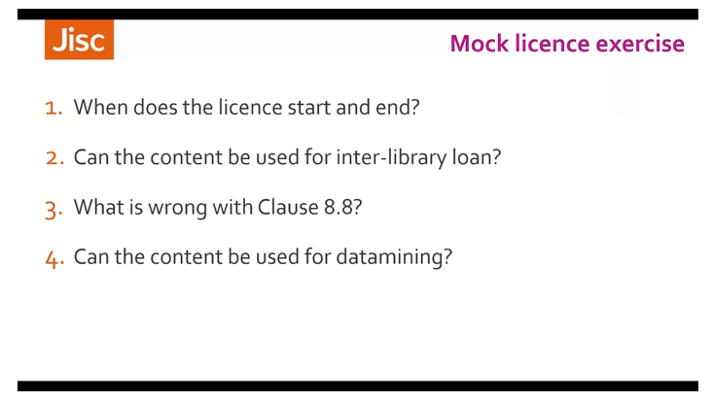
Ben: Can someone who would like to speak, tell me number of the clause or clauses where that information can be found.
And so, we thought it was 8.1 and 8.2. that it would start on the date of the signatures of the agreement. And then the license automatically renews unless the institution cancels waste by giving 60 days' notice.
Ben: Perfect! Yes. Thank you
Audience: Can I ask, in relation to that point, so you mentioned that Jisc prefers to avoid automatic renewals and you'll have your agreements running fixed period.
And I can absolutely see the benefits that, because we have quite a lot of licenses directly with the publishers, which are an agreement with subscription, which takes years and years ago, or it was for a perpetual purchase.
And the licenses become increasingly obsolete looking, and you're fair activism in some of this stuff, just seems very out of date and out of touch now ..., and I wondered if you had any advice or any kind of best practice management, on trying to approaching publishers to ask for updated licenses Would it be a case is going directly to the publisher and saying, this licenses is from 10 years ago. Is there an updated one that you can give that would be issuing to instructions if they took it out now?
Ben : And, I think that's very good idea. There are problems with automatic rollovers.
They can have implications for post cancelation access in this particular Mock license.
When we come to look at the post cancelation access, then we'll see that has implications for when the license ends and if that's not clear then that's a fault, and licenses can also become obsolete or they can fail to incorporate new laws that may have come into force.
All the license has been in progress, so yes, in that situation, I would certainly recommend. speaking to the publisher, or the supplier, and asking for a more recent version of the license. OK, thanks.

Moving on to the second question. Did anybody find the clause where, the answer to that one is can the content to be used for interlibrary loan.
Audience: So, I am saying 3.1.2,
Ben: Yes, that's exactly right. Although that clause doesn't actually include the phrase, interlibrary loan. That is the clause, that grants that permissions.

Ben: Moving on to clause 8.8, and what's wrong with that, this was a bit of an easy one I thought. Just to give you a bit of confidence, because would anyone like to answer that. What's wrong with clause 8.8?

Audience: It refers to another clause that doesn't exist. Clause 4.1.7 lose floor, plate 1.7.
Ben : It does. Exactly, thank you. This is the sort of thing that can happen if a license is amended or a particular clause has agreed to have been removed from the license. There might be a subsequent clause that refers back to the clause that has been taken out, which also wouldn't need a mandate as well.
There's actually a second problem with that clause, I don't know if anybody is spotted.
1:34:18
Audience: I was thinking that this, it may be too restrictive. So, is it I would think that authors should be able to retain copies of their articles anyway?
Ben: That's a good point. That wasn't quite what I had in mind. I was asking for something, again, a bit easier, a little bit more straightforward than that, but it's a very good point. It is a very restricted clause.
Ben; Well, the answer is that it includes. It includes terms and capital letters, um, which aren't listed in the definitions. Any capitalized words or terms in a license should have a definition, in the list of definitions at either the front or the end of the license, explaining what exactly, they mean in terms of this license.
Authored articles, for instance, should be defined at the beginning, so, exactly what they mean.
So, again, these are another sort of slip that you sometimes see in the licenses, that suggests that the license has been amended or things have been removed.
And proper attention has been paid to subsequent clauses that might reference those things.

Now, a question for which is slightly more complicated.
Did anybody find an answer as to whether content that is licensed through this license can be used for data mining?
Audience: It was 3.1.67 but there was a 12 month you can, but there's a 12-month embargo.
Ben: Not that one doesn't specifically permit data mining that permits depositing articles in a repository.
So, it's not specifically data mining. Did anybody else find anything about data mining?
Audience: I couldn't see anything specific to data mining. Well, if you look clause 3.2, the license will complement and extend the rights of copyright designs and patents Act, and knowing in the copyright act that there's the text and data to mining exception.
Ben: That's a good answer, yes.
There is nothing in the license specifically to permit data mining, right?
Audience: I think 4.1.3 clearly states that you are not allowed to adapt the licensed material, except for display on the screen. For data mining, you would have to adapt the licensed material, especially with natural language processing.
Ben: OK, I don't, personally, I don't take that specifically to restrict data mining, although it's a good thing to think about.
My opinions? And this is only, my opinion is that this license is silent on data mining and as someone mentioned and If the license doesn't specifically mention something a use, particular use of the content that we need to refer to what the wider the law says, in this case, the law copyright?
As it mentions, in clause 3.2, that we would have to find out whether use for data mining is permitted by the law of copyright. Which, if it's done purely for academic purposes, it is in the UK.
But, again, that's is a good example. When a license isn't clear, we might need to think more widely or seek, wider advice.
Good, those are all good answers,
Audience: can I just ask a quick question, if this is, if data mining, is something that your institution is particularly keen in having, would you then recommend having some sort of a clause inserted that explicitly says in one way or the other?
Ben: Yes. Yes. That’s, actually something we'll be looking at, in the next exercise, so hold on to that thought I'm going to move on.
Ben: We're just going to move on to the next few questions, And I'll give you another five minutes or so, to have a look at these, and then come back. So, just have a look at the next three questions.

Ben: OK, halfway let’s go on with those three questions that are a bit more complicated than some of the earlier ones.
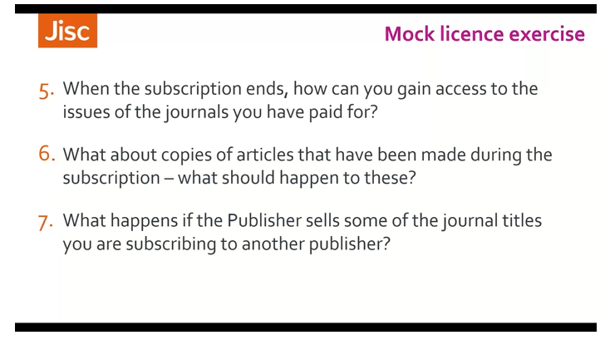
Now that we're getting the hang of looking at the license or finding our way through it, question five.
When the subscription ends, how can we gain access to the issues of the journals that we've paid for during our subscription?
Can anyone tell me the clause that sets that out?
Audience: 8.5?
Ben: 8.5, Yes, that's the correct one. Is everybody happy with that clause do they think it's clear?
Do they think that if they did cancel their license, cancel their subscriptions? That know exactly what it was that they would get access to, and how they get it?
Audience: I was going to say it varies between Publishers, what they consider to be archival or background material and front file material, so I wouldn't be clear, what we're retaining access to.
Ben : Yes, you're right. That it does vary. And it varies between suppliers and it varies between agreements. As I mentioned earlier on, this is something that's becoming increasingly important when people to do consider cancelling subscriptions and especially cancelling, publishes big deal subscriptions.
It's very important to know what you will retain access to. If you do cancel.
There are various things in that, that I would perhaps seek more clarity on the from the publisher.
It mentions a reasonable fee and who gets to decide in point one there, what a reasonable fee is.
Also, it mentions, that it will supply the full text of the license material, which was published during the term of this license. Again, that might not be very clear exactly what that would be. So that might need a little more clarity. It's also worth considering that one of the options that it offers for ongoing access is through Portico, which, although widely used, is obviously a third-party supplier.
And we'll require its own license agreement with you, and it's a subscription fee to access content through that.
So, a few things to look out for there a few things that perhaps you might approach a supplier and ask for a bit more clarity on.

Ben: What about Question? six, Copies of articles that people might have made during the subscription?
Quiet, legally, under the terms and conditions here?
Has anyone found the source that sets out what should happen to those?
Audience: Clause 8.7?
Ben: It was 8.7? They must be deleted from the institutions, servers, or networks?
Ben: What do people think about that? Is that a reasonable expectation?
Audience: This is not a reasonable expectation and it also leaves room for too much in interpretation.
how does the publisher certain that this has happened?
I mean, if, if I couldn't get such a clause out of the license, then I would recommend all users to store the material on USB sticks, personal, hard disks, et cetera, so that they can retain their copies.
Yeah, we, we try to get it out, um, from our licenses.
Ben: But you have seen clauses like this and licenses.
Audience: Yes.
And I had a rather vigorous debate with one publisher, um, where I tried to reason and say, well, at least for good academic practice, academics, scientists need a copy when they quote from it.
And it culminated in the publisher telling me that if we are serious about it, let's admitted, academics quotes papers without ever reading them, so they don't need copies and they can delete it.
Ben: Good. Yeah. This is a clause that you will often see in a license. license, as I often see it in. publishes license's, who tend to deal with the corporate sector rather than the academic sector, often business or financial databases that rely on very up to date information, so they don't like the idea of people copying and then using information that would later be out of date, but it is something that is that you often see in scientific research material as well.
So, there is a reason behind the publisher wanting to wanting you to do this.
But I would say that it's unfeasible to expect an institution or a library to enforce this on its authorized users, and it puts you at too much risk of breaching the license to accept that. I would very strongly push back against a clause like that, and an agreement.
And rarely, if copies are made, and they used within the terms and conditions of the license, then I really don't see a problem, but it's certainly one that should be pushed back on.

Audience: Just in terms of pre reading the license, am I correct in thinking about clause 3.1.6 ? It's saying that you can't save anything more or print out anything more than one page. So, even then, like the copies you would make would be a page worth of copies. Am I reading that, right?

It's 3.1.6, allow authorized users for educational purposes, only two. And you have the people who can access my social electronically, safe parts, not more than one page, the licensed material for personal use. Print out single copies of parts not more than one page of the licensed material, says, is that basically saying that the most, you can save anything. So, I've, I've had that. In real licenses where there's like limits as to what you can actually you feel one page that you can save, you can't keep hold of it.

Ben: Yeah, I mean what one page is a bit of an exaggeration. My point is, and including that, is that you often see stipulations about the exact quantity that can be copied or print and again, that is something that would be very hard for allied way to enforce.
So again, that would be something that should be pushed back up for any questions. So, it's good point.

Ben: Moving on to question seven.
Did anyone find an answer to this? What happens if the publisher sells someone the journals you’re subscribing to another publisher?
Did anyone find a clause? That refers to this.
Audience: 10.2?
Ben: 10.2, gives the publisher the right to change the content. Yeah, including removal of an entire journal, unceasing to have the right to publish.
Um, that's pretty standard in the Jisc mock License that we were looking at earlier, see if I can find the clause. We have more detail on this?
I haven't got it with me at the moment, but we do have specific clauses that say, what would happen in the event of titles, transferring to another publisher?
Audience: A quick question is 5.2 as well sufficient, in this case, the publisher reserves the right at any time to withdraw from the licensed materials, any item or part of an item for, which the Publisher no longer retains the right to publish and for which the publisher has been unable to secure. Maybe it's just me.
Ben: Now, that's right as well, so, these are quite standard clauses, in the Jisc model license, that we were looking at earlier. If you look at clause 16.3 in there, it gives much more details about what should happen in this event, which, again, gives you a decent audit trail if you're looking for access to content again, after the end of the license, the post cancelation access.

Ben: Let look at the next three questions.
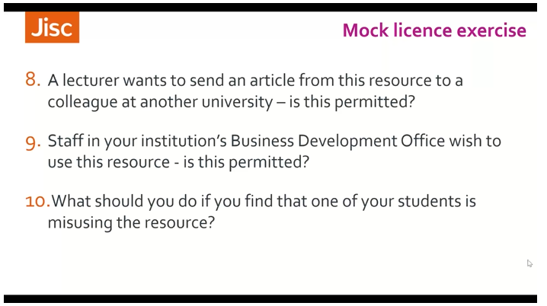
Ben: So, the first one question I'm a lecturer wants to send an article from this resource to a colleague at another university. Is this permitted by the license. What do people think?
Audience: I would say no, because 4.1.4, and 4.1.6 - Distributing licensed material, and providing access to any not authorized users. So, I would say that if their colleague at another university is as an authorized user, in their own right. they should access it via their own university channels or via an interlibrary loan or via one of the methods that are permitted in the license. But not via lecturer, just sending it to somebody else.
Ben: Yes, that's a good answer. I think technically, strictly under the terms and conditions of this license, this isn't permitted.
Some licenses will permit something called scholarly sharing, which is more of a concept in the States than it is in Europe or suddenly the UK. You don't see it in UK licenses, very much, but scholarly sharing. It's this sort of thing.
Sharing articles with other academics. And, I imagine that it happens a lot, and that this question is slightly unrealistic because the lecture would probably never come into the library and ask whether or not they could do it. They would probably just do it, and it probably would never even occur to them that it wasn't permitted under the terms of the license. But strictly speaking, as xxxx said, under this license, it wouldn’t be allowed.
Ben: Now, question nine, staff, in your institution's business development office, or could be any other office that's to do with the running of the universities, such as the estate's office, or the buildings department, or even the, the alumni office for instance, they wished to use this resource.
They want to make use of that institutional subscriptions. Is this permitted to thing?
What are people's views on that under the terms and conditions of this license?
Audience: They are staff members so yes, I would permit it all I would flat with them, is that it is to be used for educational purposes, such as the Business Development Office if there was anything commercial involved in their use they'd have to get a different license or permission to use that and it would be the same message to any of the department in the University.
Ben: Yes. Yes. That's again a very good answer.
Audience: Sorry, it's just a UK based member of staff institution. So, they have to be in the UK if the office was in a different country, without their problem.
Ben: It wouldn't be under the terms of this license, yes. But if they were in the UK and they're a member of staff, then yes, they would be permitted as an authorized user to use this resource.
But they would have to be aware that the use, they were permitted to make the resource should be for study, or teaching, or education only, and they shouldn't be using it for any commercial purpose.
Again, this can be an issue if your subscribing to business resources or standards, resources that can have a use beyond an educational context. And if this is the case, then, as xxxxx said. Those departments should look to get their own license or their own subscription to this resource.
Ben: Finally, we talked about earlier on that a license should be clear, about what should happen if something goes wrong.
What should you do if you find out that one of your students is misusing this resource?
Did anybody find the clause that sets that out?

Audience: Point 6.1.5:
Ben: 6.1.5 point 5? Yes, that's the correct answer. Well done.
This calls upon the institution to monitor compliance and says, what should happen if they become aware of any breach.
Now, the wording of this clause is particularly good because it allows the institutions to initiate disciplinary procedures in accordance with it's standard practice, that's to say it's giving the institution the right to take action here rather than the supplier, whose action would usually be cutting off access to the entire site in the event that it discovered an abnormal activity.
So, this is good wording because it allows you to take control and use your own institutions, disciplinary procedures.
Audience: One question because in the mock license, it says that the licensor will provide full particulars. Isn't that problematic, because with full particulars, couldn't? Then, the publisher, could also demand the name of the student?

Ben: Yeah, that might, that is something to consider. But, in this, um, I would say this wording to remain full particulars of the unauthorized access or use. I mean, there's more.
Something else that's good about these clauses is that they include the wording use all reasonable efforts rather than wordings, such as insure or undertake which, again, gives the institution some leeway.
Carolyn: We’ve covered most of the questions. This actually came in generally. Is there some were a list of questions like we've been going through here that would be useful to consider when looking at the license? Is that the sort of thing people have in their own institutions?
And I think somebody else has written, you've responded to xxxxx and said when you were at xxxxx, you had a checklist and a license terms guide, and you had ideal versions of clauses that you try to use.
So, that sort of thing Ben really, I mean, we obviously use our model license as our guide, but it might be that there are some key things that you always want home in on. Do you have any comments on that?
Ben: We Yeah, as you say, we use our model license. There are there is a guide to our model license on our website that we mentioned earlier which focuses in on the key clauses.
Um wow, apart from that I don't really use anything, although obviously there are books and guides available. I'll try and find some and perhaps distribute them afterwards.
Carolyn: I think that was the main one that came through that I noted.
Ben: OK, OK, thanks, Carolyn, and thanks everybody, for your participation in the last session. I thought it worked pretty well, and I hope you've got a lot out of it.
As I mentioned, there were other things in that mock license that are worthy of attention or worthy of calling into question that I didn't ask specific questions about, so by all means, carry on, and look through it. And this is anything you want to ask me about, get in touch.
I don't want to go on too much longer, because I think it's important to keep these sessions, quite brief.
Because I'm aware that online, sort of, attention to wander and which is why I'm keeping them to an hour, but I just want to discuss briefly what we're going to be doing tomorrow.
Um, and we have, um, another exercise.

